|  |  |
| --- | --- |
|  | **engduino®**Tutorial  Engduino Support Team - support@engduino.org |

Using Accelerometer to measure Distance and Height

# Overview:

Engduino has a 3-axis xyz-accelerometer built in. This would allow us to apply trigonometry to calculate the angle between the axes and turn it into many interesting applications. This example will use the accelerometer on Engduino to calculate the angle. By applying trigonometry, we can measure the distance and height of an object.

# Aim:

This tutorial aims to guide you through on how does an accelerometer works and gives you the steps to create a MATLAB application that measures distance and height.

# Objectives:

* Understand the working principle of Accelerometer
* Use Accelerometer reading to calculate the angle
* Apply trigonometry to calculate distance and height of an object
* Turn it into a MATLAB GUI application with GUIDE (Optional)

# Learning Outcomes:

By the end of this tutorial, you should be able to

* Understand how does an accelerometer works
* Calculate angle using the xyz-axis on accelerometer
* Use tan, cos, sin function in MATLAB
* Create MATLAB Gui with GUIDE

# Pre-requisite

* Engduino MATLAB Support toolbox and MATLAB installed
* Engduino configured to make it discoverable in MATLAB

# Tutorial

If you have gone through our previous example that uses the accelerometer to get acceleration, then double integrate it to get the distance, you should realise that the measurement is not very reliable. In fact, most of the time it does not work quite well.

As such, in this tutorial, we are going to use a much more reliable approach, which is using the angle given by accelerometer, apply the trigonometry to calculate the distance and height.

**1. Understand how an accelerometer works**

First, let us explain the working principle of the accelerometer to help you better understand why using the angle to calculate the distance is better than using acceleration. Imagine that the accelerometer is like a box with a ball in it.

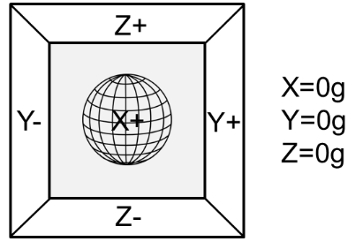If there is no gravitational force or any other fields that might affect the position of the ball, the ball will simply float in the middle of the box. In this case, without touching any sides of the box, the accelerometer will measures 0g on all three axis.

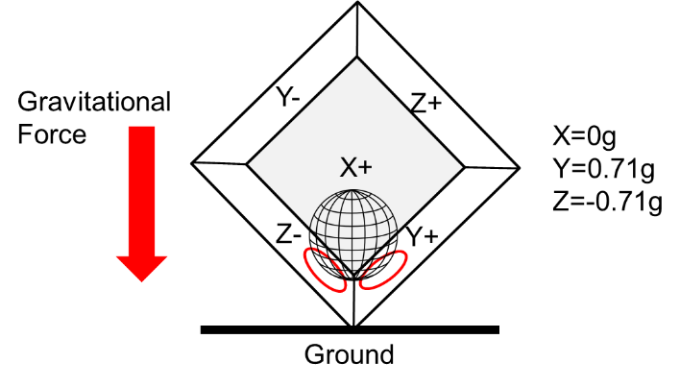 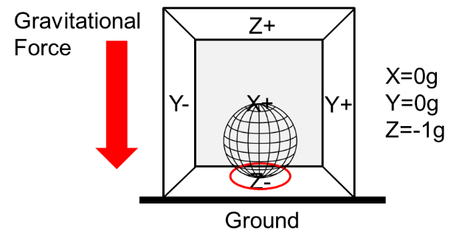

If we take this model and put it on earth, the gravitational force will act on the ball and cause it to touch the sides of the box. Imagine that the sides of the box are pressure sensitive, the accelerometer will detects this pressure force and gives the reading as shown in the above model. We can compare the readings to get the orientation.

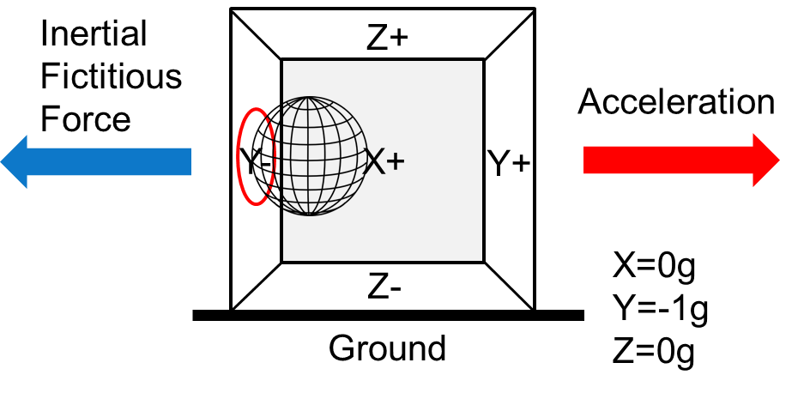

In the model above, we move the accelerometer to the right, the ball will move in the opposite direction of the acceleration due to inertial fictitious force. The accelerometer will gives the reading of this force which is directed at the opposite direction of the acceleration. However, in this case we are assuming that this force is purely our acceleration, but in reality, shaking, rolling can also add forces to the acceleration and the accelerometer cannot differentiate these forces. As the result, there will always be error in the calculation. In comparison, you probably notice that accelerometer performs better at giving the angle and orientation than giving acceleration. Thus, using angle gives us a more accurate result.

**2. Work out the direction of the angle**

Try to work out the angle when you rotate the Engduino. Figure out the xyz-axis of the accelerometer first. Plug in the Engduino to the computer, launch MATLAB and create a new script. Use the code below to connect to Engduino.

if (~exist('e', 'var'))

e = engduino();

end

This code will make the connection to Engduino. Ensure that MATLAB is able to connect to Engduino by checking at the message in the command window before you continue.

Once you have connected the Engduino, stop the script and add the following code below the existing code.

while(1)

newReading = e.getAccelerometer()

pause(0.5);

end

This code will read the accelerometer and returns the xyz axis readings respectively.

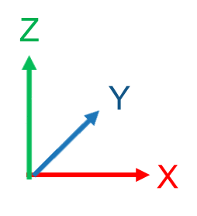Work out the axis, you will get approximately either -1g or 1g on the z-axis if you lay the Engduino flat on a table.

Once, you have figure out the xyz axis of the accelerometer, proceed to find out the tilt angle when you rotate the Engduino. You can use cos, sin, tan to find out the angle in between two axis.

Modify the while loop to the below.

while(1)

newReading = handles.board.getAccelerometer();

gx = newReading(1);

gy = newReading(2);

gz = newReading(3);

angle = atand(gz/gy);

end

This code stores the xyz reading of the accelerometer to gx, gy, gz respectively. The function “atand()” perform $\tan^{-1}$ operation. Try this on different axis and find whether this makes sense to you.

**3. How to get distance and height?**

Now that you can get the angle between the rotations, think about how to get the distance.

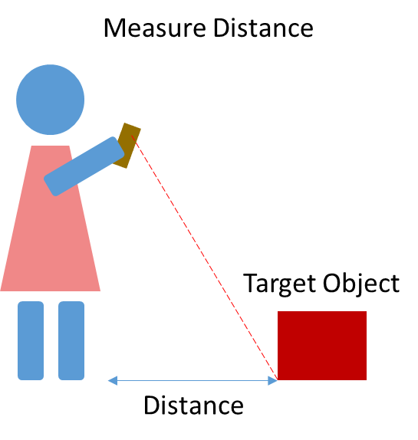You want to measure the distance between the target object and you. Given that the accelerometer on the Engduino is able to give you the angle, how can you calculate the distance by pointing the Engduino at the object that was on the floor?

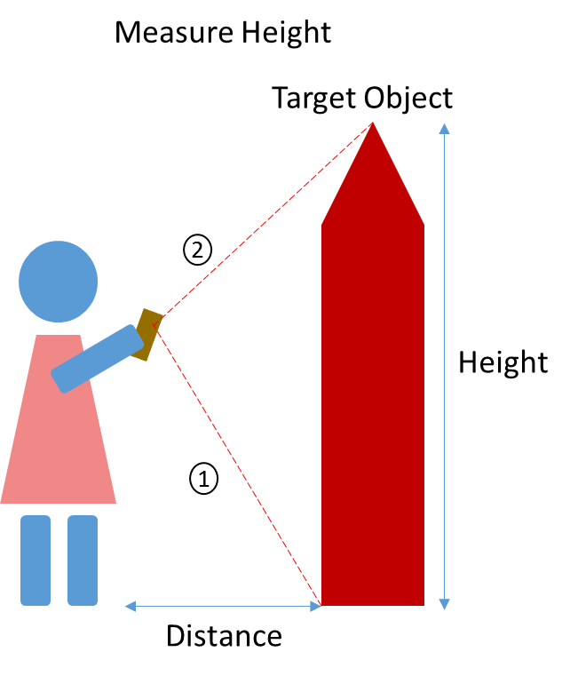Similarly, think about how you can measure the height of the object that is placed on the floor.

Try to work out the equation before you turn into the next page for answer.

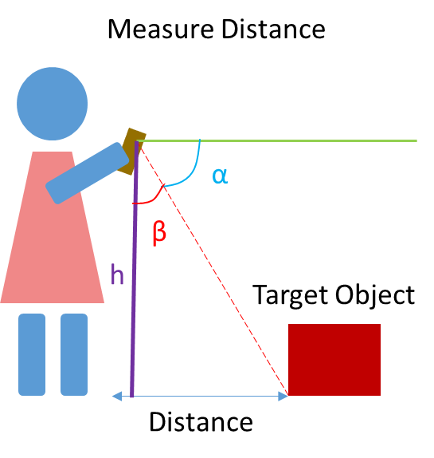Let us assume h as your height - 0.3m. You should be able to calculate the angle α and β by pointing the Engduino on the target object.

In our example, we use the Z and Y axis on the accelerometer to calculate the angle.

$α=\tan^{-1}\left(\frac{z}{y}\right)$

Now, we can calculate β.

$β=90- α$

The last part to calculate the distance,

$Distance=h tan($ β)

Using the above equation, the distance d is known. The accelerometer can continue to give us the angle α. So to calculate H, we have two cases, the object is lower than us or the object is higher than us.

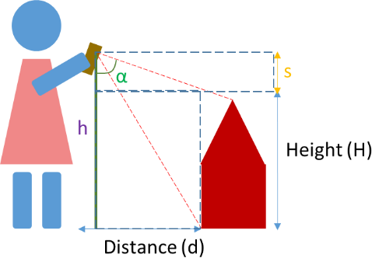

The object is lower than us. We can get S simply by $S=\left(\frac{d}{tan\left(α\right)}\right)$

This will give us a positive value. To get the object height, we just perform the following. $H=h-S$

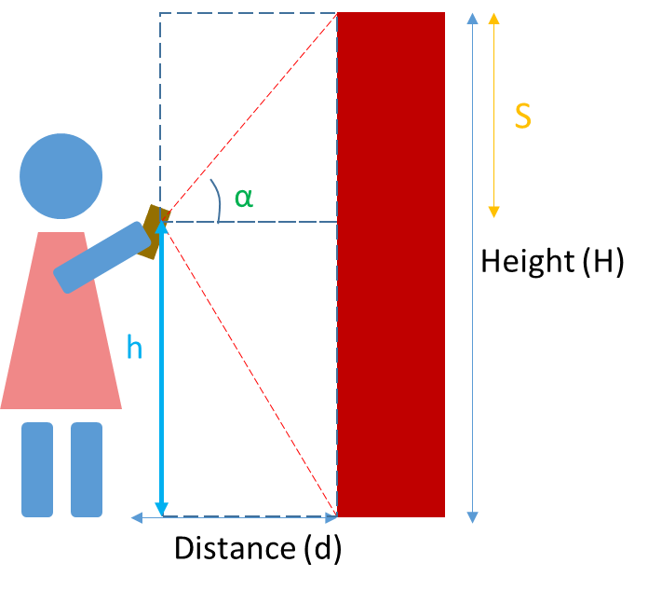The object is higher than us. We still get S with the same equation. But now S will be a negative value. As such we can still apply the same equation as above.